**POOLRota**

***A documentation submitted in partial fulfilment of the***

***requirement***

***Submitted By***

**Name of Group Member – 1**

**Name of Group Member – 2**

**Name of Group Member – 3**

***Under the guidance of***

**Mr. Blah blah bleh**

**Mr. Blah blah bleh**

**Mr. Blah blah bleh**

**Members of app development team of rotatract**

**License by apache 2.0**



**Table of Contents**

List of Figures………………………………………………… i

List of Tables…………………………………………………. ii

Abstract……………………………………………………….. iii

Chapter 1. Problem Identification……………………………. 1

Chapter 2. Feature Finalization……………………………….. 2

Chapter 3. Design Flow………………………………………. 3

Chapter 4. Conclusion and future scope……………………… 5

References (If Any)...………………………………………….. 7

**List of Figures**

Figure 1.1: Figure 1…………………………………….1

Figure 1.2: Figure 2…………………………………….2

Figure 2.1: Figure 3…………………………………….3

Figure 4.1: Figure 4…………………………………….4

**List of Tables**

Table 1: User details………………………………………………3

Table 2: Details to be filled by user………….……………………4

**Abstract**

*Carpooling is one of the latest technologies discovered which has made travelling convenient and efficient to the common man. It also known as car-sharing in which one can travel to their destination while sharing the vehicle and the expenses incurred. Hence fuel costs, tolls and the stress of driving will be reduced when more people travel together in one vehicle. Carpooling is also an environment friendly app and we can save our mother nature by using this app. It also helps in reducing traffic congestion, and other poisonous gases in the air. We can save a lot of space in the Parking lot. During high fuel prices and high pollution periods, making use of the car pooling system is an intelligent decision.*

*In our application, we will make an Android based application that will allow passengers to collaborate with other like-minded people and plan out their journey using the easy UI of the app after signing in to it.*

*People will be able to share expenses and not worry about reaching late while making new connections*

# Chapter 1

**Problem Identification:**

*Carpooling is such a necessity in today’s generation since the fuel prices are rising up and places to travel in a day are more than one. People who are rich and can afford a car on daily basis need not think twice before spending it.*

*But common people like us need to save on the travel efforts. So our carpooling system will not only ensure your safe journey but will also give you an affordable ride anywhere and anytime in this city. Carpooling will help on fuel expenses to fall down and many more advantages.*

*the following students (general body members) of rotract club Chandigarh Himalayan have been*

*facing problem while traveling to meetings from long distance away since many members come from different universities and other places in tri city.*

# 

# Chapter 2

**Feature finalization**

*The Carpooling application will be implemented in Android operating mobile phones. It works on simple mechanism.The application will try to cover the following:*

* + *User accounts for both the ride providers and the ride seekers.*
  + *Use GPS to find nearby carpoolers.*
    - *Find optimum paths and allow carpooler to choose one from it.*
    - *Integrating google maps so that the ride provider can provide his detailed route and then the potential passengers can view and decide their boarding and de-boarding point.*

*In this application the user will be able to interact with the driver and book his seat easily. The user has to download this app and register themselves for carpooling.*

*They will enter the source, destination and other details. These details will be stored in the database to maintain records.*

*If he/she is a passenger they will be given options to select a driver of their choice. If he/she is a driver they need to provide a valid licence no. and their other details correctly.*

*This app is being developed for Android 5.0 and higher versions.*

*The database table that we will use will consist of the following tables:*

**Table 1 :** User Details

|  |  |
| --- | --- |
| **Id** | Unique identification for every user. |
| **Personal info (name, address, ph no, email id, gender, dob,**  **photo)** | The database will hold personal information of each user in case of any discrepancies. |

**Create a Pool**:

*A user who owns a vehicle can create a car pool with the following details. These details will be published on the app via which the passenger can select the appropriate driver for his/her travel.*

**Table 2**: Details to be filled by the User

|  |  |
| --- | --- |
| **Event Id** | A unique identification for each car pool event |
| **Pickup** | The start location needs to be added |
| **Drop** | The final destination needs to be added |
| **Purpose** | Enter the valid reason of carpool |

**Join a Car Pool & enjoy the ride!**:

*A user who wishes to share a ride can enter his source and final destination along with time and he/she can select a particular car pool to join.*

*When the user chooses to create a new event, he is given a form which has fields such as subject of the car pool, time of the car pool, vacancies in the car, destination address of the car pool.*

# Chapter 3

**Design Flow**

*Registration/Login All users who create an account for poolrota must register and create a Login profile containing details such as name, email, profile picture, mobile number and occupation. The users will be required to have a username and a password within the site.*

***figure-1* *figure-2***

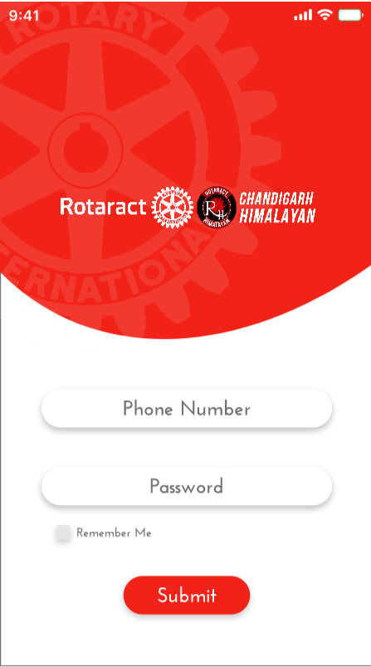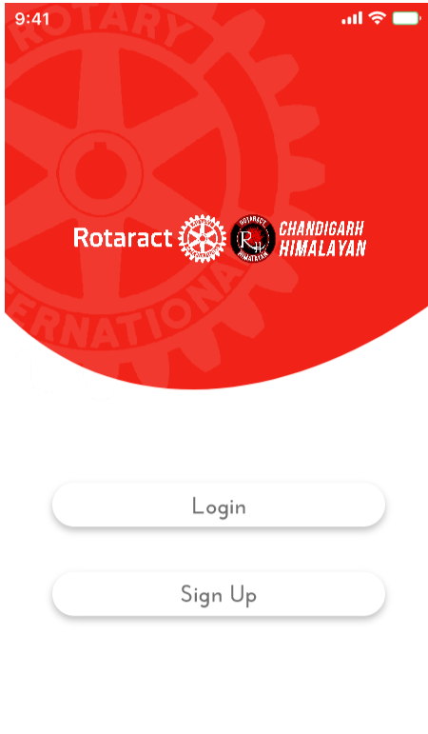

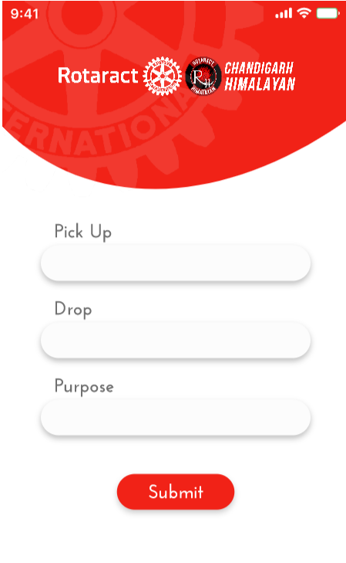

***Figure-3***

*This is the screen of application where user can offer ride for carpooling. User can offer ride from his/her current location or any desired source location to any desired destination possible via car route on map.*

*Application allows user to offer two kinds of rides namely - single ride and other is return ride (to and fro) if user wishes to offer ride on return journey too. After filling in all details required for ride, user can confirm ride and this offered ride will be made available to other users to pitch in carpool request.*

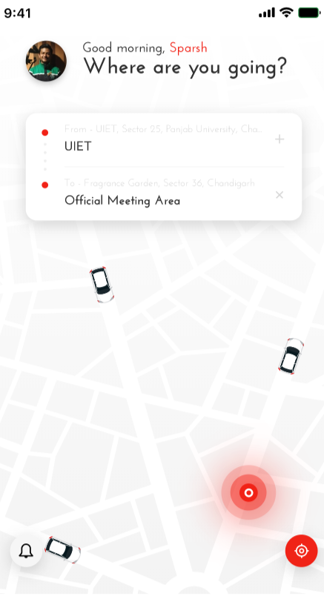

***Figure-4***

*In this page this application shows the uses Google Maps API.*

*This API is used to add maps to the application, which will inturn used to show user locations, draw journey path etc.*

*The API automatically handles access to Google Maps servers, data downloading, map display, and response to map gestures. Also there are API calls to add markers, polygons, and overlays to a basic map, and to change the user's view of a particular map area. These objects provide additional information for map locations, and allow user interaction with the map. The API allows you to add these graphics to a map*

# Chapter 4

**Conclusion and Future Scope**

(Testing report under different inputs/working conditions, percentage of the completion of project based upon testing results and features chosen.)

This paper elaborates the proposed system which consists of main modules which are Offer a login, pickup,drop, etc via Registration.This system involves support from Google maps services and GPS module to provide user specific services .an user experiences are.

The main purpose of this application is to illustrate the initial prototype of the proposed system.

(Scope of improvement for achieving the desired features)

Chat Rooms for online users to interact and co-ordinate and quick messaging Emergency button to send current location of the passenger to a pre-specified contact in case of emergency.

User profile which will have car details like registration number, color and model of the car apart from the profile photo of the user fetched from his google account.

# Chapter 5

# References

Can also include the links to buy the components online, if available